April 26, 2025



**Team,**

I suggest we open our project for other users to log in before the next presentation, allowing them to vote and provide valuable feedback. I’ve started setting this up — it's more complicated than it should be, but I’ll take the opportunity to tidy things up along the way. If you have any concerns or suggestions, please let me know.

If you haven't yet **reviewed the videos**, now would be a great time. This will help us test the feedback functionality more broadly and identify videos that you personally find compelling. Also, please make sure to pull the latest version of the main branch.

**Reminder:** Please practice good repo hygiene. Don't let branches run long without merging properly. As per guidance from Tony and Shane, **always merge into main on your local machine before pushing back to GitHub**. This will help us optimize our outcomes and avoid conflicts.

Use old Kanban

**If we want to add anything new to the product, now is the time to decide.**Please bring your ideas to Monday's stand-up and come prepared to contribute effectively. Current ideas include:

* Adding **captions** to all videos showing the camera number and location.
* Add “like” count overlay on each video.
* Add watermark to each video.
* Create a **leaderboard** for videos and user participation. *User participation could include digital rewards and incentives to foster engagement.*
* Enable users to upload personal videos.
* Find and incorporate additional video and image sources from around Calgary, such as other City APIs.
* Build interval-based image harvesting and video production logic based on popularity or specific events (e.g., Stampede, major weather events). (*This idea was encouraged by feedback during our presentation. The harvesting and production code is modular, so it's simple to add — but even just mentioning it as future potential could serve as an attractive "shiny lure" during our pitch, and is a better strategy.*)
* Add Favourites section
* Add text
* Add back in functionality
* Improve responsiveness
* QR Code!!
* Add authentication

Our initial presentation went well — we even had about three minutes of extra time that could be filled with highlights of additional opportunities. I recommend we keep the focus on **positive outcomes** moving forward.

Reagan has asked that staff from **Calgary Tourism** attend our next presentation, as they may have a strong interest in our product.

Also, the presentation and the web product could use a little refinement to better align with the **Blue Sky City** look and feel. (It should be relatively straightforward. For reference see: <https://www.visitcalgary.com/>). I’ve already done some work on this, including changing our handle from Blue Sky City Watchers to Blue Sky City Reactive, and a few other subtle changes.

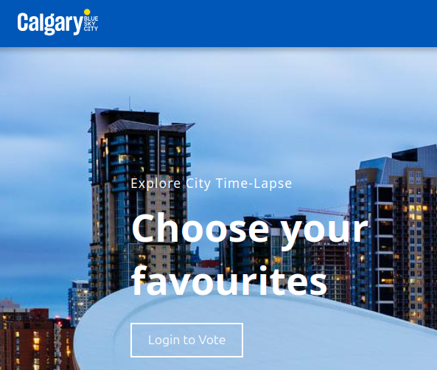

I also added a popup on hover over our copyright text, as follows:

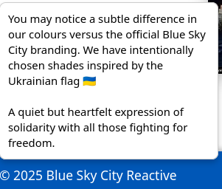

If anyone finds this objectionable, let me know and I’ll remove it. I think we all need to be okay with including this.

**Action Items for the Next Week:**

* Review the recording of our demo once it's posted to Disco. (Reagan mentioned she would upload it soon.)
* Provide constructive feedback on the presentation.
* Think about which part you'd like to present or support during the next session. Prepare and practice.
* Continue active, enthusiastic participation as we polish our product and pitch.

*We had very little time to prepare for our first presentation and no time to rehearse — so the next one should be much better. I'm fully prepared to cringe at my own contribution, but that's how we get better. Let’s all help each other hit this out of the park. As mentioned, we had 3 minutes remaining at the end, so we can add a bit more depth if necessary, or slow the pace a bit to remain chill and encourage engagement. If we are able to enable other users to access the app, we should easily chew up the extra time.*

During the week, it would also be good to **chat with our cohort** and **subtly encourage** them to ask us questions that guide the pitch in the direction we want. Let’s do the same for their projects — mutual support benefits everyone!  
  
Thank you all for your effort.

Should we consider a theme music for our presentation? A quick search online reveals a few options on the Blue Sky theme. Each is about 3 minutes long so we could open with one, fade the music as we present and roll out with another.

1. [Electric Light Orchestra - Mr. Blue Sky](https://www.youtube.com/watch?v=G8dsvclf3Tk)
2. [Diana Krall - Blue Skies](https://www.youtube.com/watch?v=ZKO1PqN2dj8)
3. [ikson - Blue Sky](https://www.youtube.com/watch?v=zc4ET9viVQ0)